**Lab Exercise 10– Creating Multiple IAM Users in Terraform**

**Objective:**

Learn how to use Terraform to create multiple IAM users with unique settings.

**Prerequisites:**

* Terraform installed on your machine.
* AWS CLI configured with the necessary credentials.

**Steps:**

1. **Create a Terraform Directory:**

**mkdir terraform-iam-users**

**cd terraform-iam-users**

* Create Terraform Configuration Files:
* Create a file named main.tf:

**# iam.tf**

**variable "iam_users" {**

**type = list(string)**

**default = ["user1", "user2", "user3"]**

**}**

**resource "aws_iam_user" "iam_users" {**

**count = length(var.iam_users)**

**name = var.iam_users[count.index]**

**tags = {**

**Name = "${var.iam_users[count.index]}"**

**}**

**}**

In this configuration, we define a list variable iam_users containing the names of the IAM users we want to create. The aws_iam_user resource is then used in a loop to create users based on the values in the list.

1. **Initialize and Apply:**

Run the following Terraform commands to initialize and apply the configuration:

**terraform init**

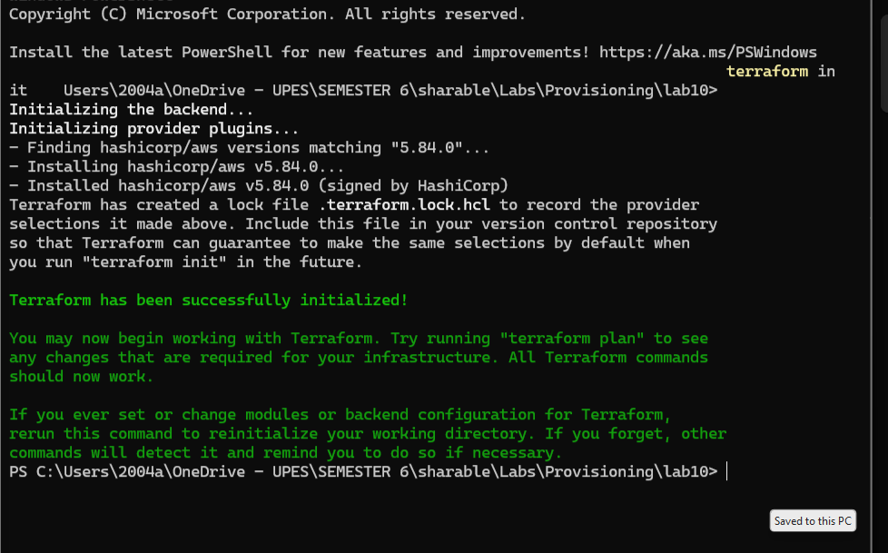

**terraform apply**

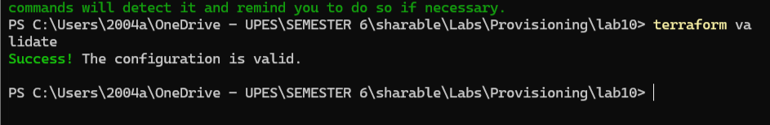

Terraform will prompt you to confirm the creation of IAM users. Type yes and press Enter.

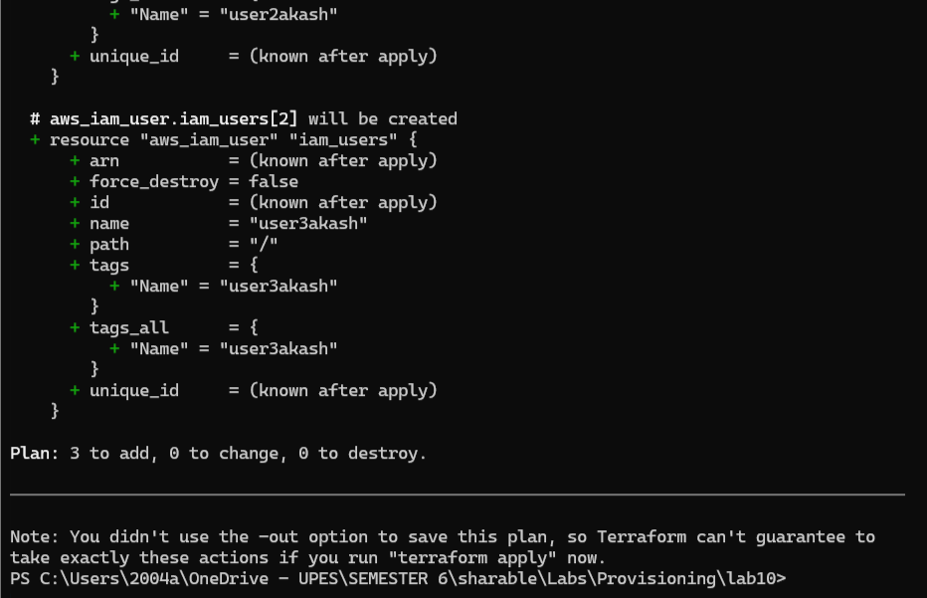

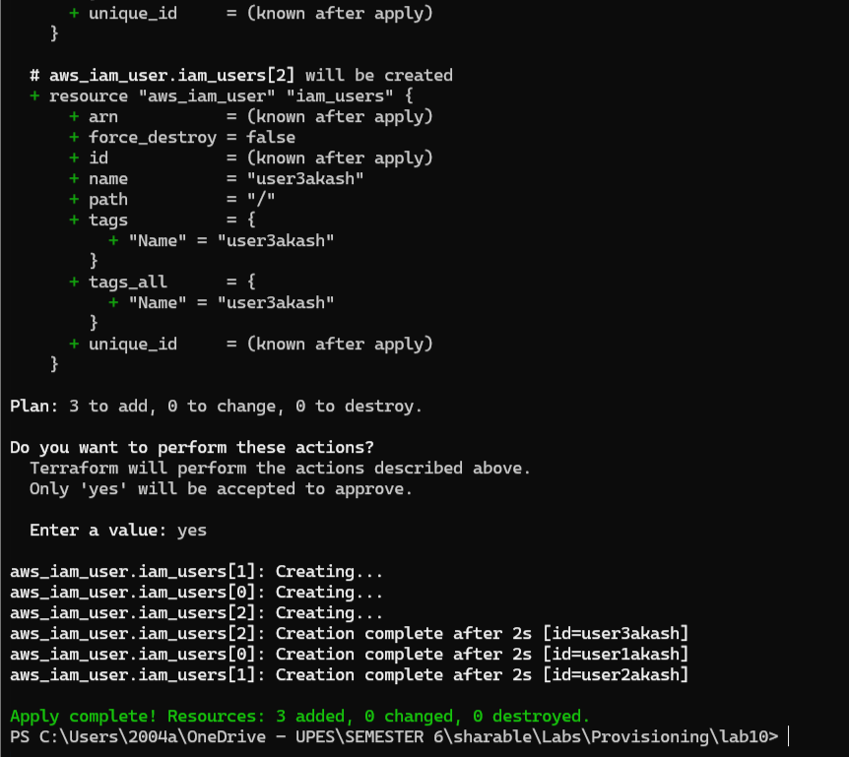

1. **Verify Users in AWS Console:**

* Log in to the AWS Management Console and navigate to the IAM service.
* Verify that the IAM users with the specified names and tags have been created.

1. **Update IAM Users:**

* If you want to add or remove IAM users, modify the iam_users list in the main.tf file.
* Rerun the terraform apply command to apply the changes:

**terraform apply**

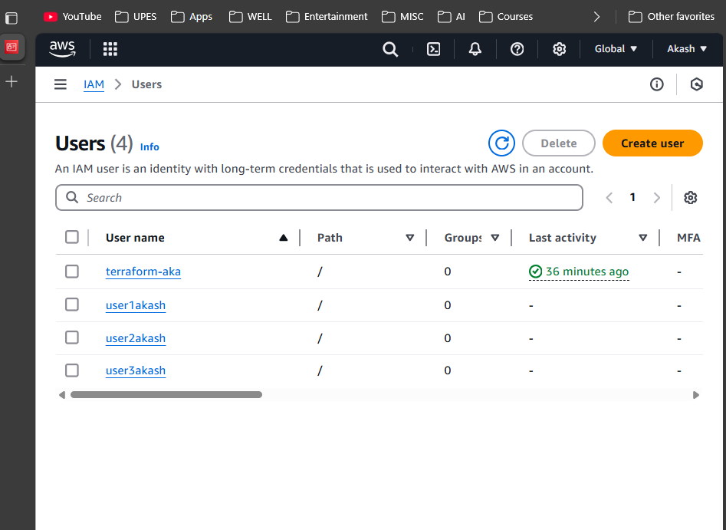

1. **Clean Up:**

* After testing, you can clean up the IAM users:

**terraform destroy**

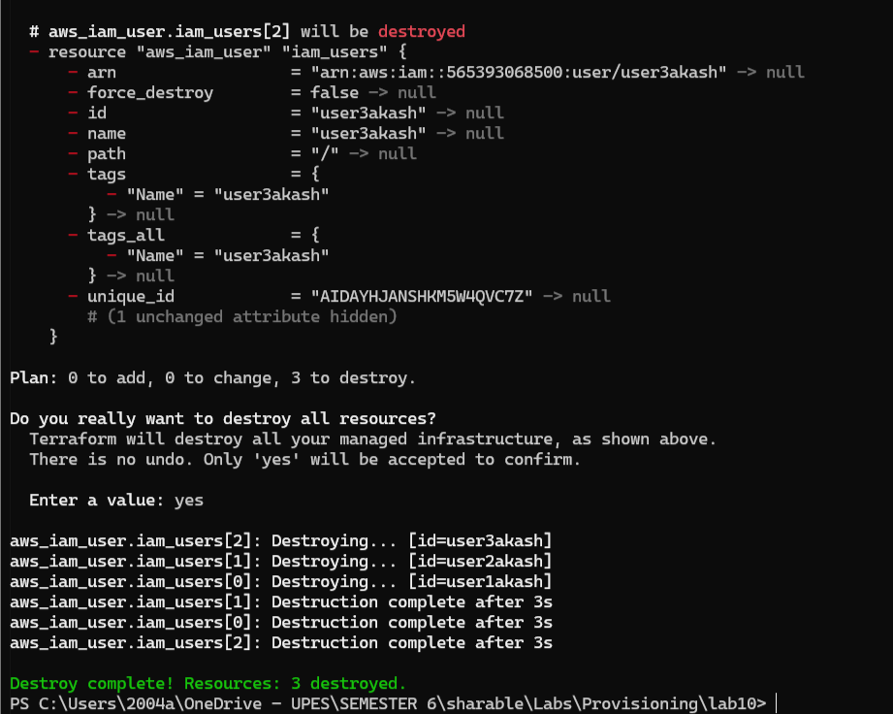

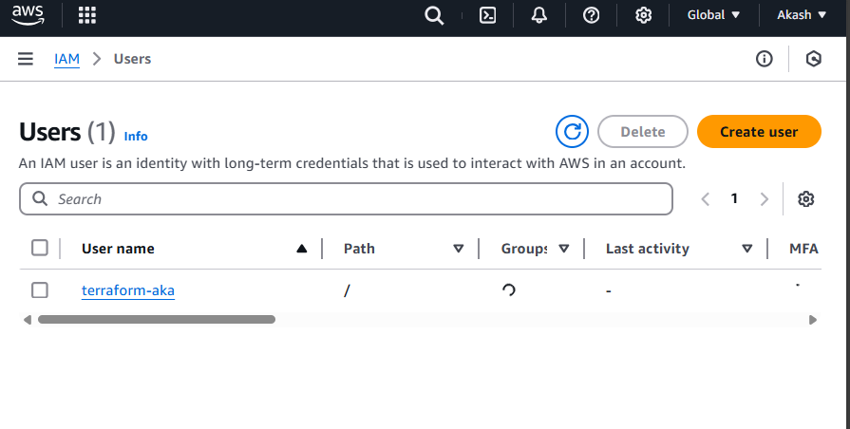

* Confirm the destruction by typing yes.

1. **Conclusion:**

This lab exercise demonstrates how to create multiple IAM users in AWS using Terraform. The use of variables and loops allows you to easily manage and scale the creation of IAM users. Experiment with different user names and settings in the main.tf file to understand how Terraform provisions resources based on your configuration.